SolidCAM Export from MachiningCloud

Setup and Installation

  - Download .zip file from https://www.machiningcloud.com/solidcam/ and extract to
    - C:\Program Files\SolidCAM2025\Solidcam\PlugIns\ToolTable

Import to SolidCAM
- Open the ToolKit
- Select “Import Tools from Third Party”

- Scroll down and select MachiningCloud
- In MachiningCloud, search for your tool or go to your already saved assemblies and jobs
- Once your tool is selected, click “Export”

- From the Export options, select SolidCAM
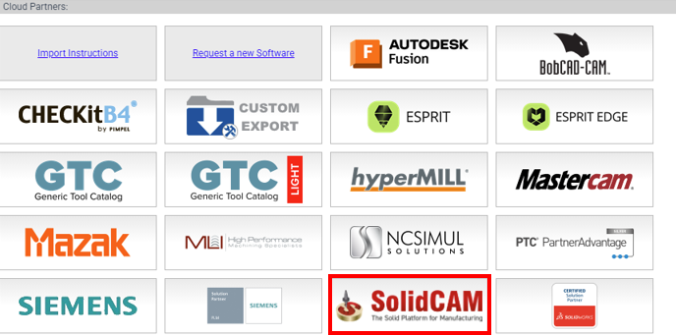
- Once export is complete, download the file
- 